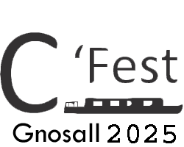

**Gnosall C’Fest July 18th - 20th July 2025**

**Boat registration form**

If you wish to secure a mooring at the second Gnosall Canal Festival please complete the following details and email them to [cfest.gnosall@gmail.com](mailto:cfest.gnosall@gmail.com)

**Contact Details**

Name:

Address:

Postcode:

Telephone No: Email:

**Narrow Boat Details** (all boats attending must have a Canal and River Trust waterways license and be fully insured)

Boat Name:

Boat Length: (including fenders)

Number of people on board:

Canal & River Trust Boat Licence Number: Expiry Date:

Boat Insurance policy details (to include insurers and expiry date):

**......** Expected arrival date:

If opening to the public Canal and River trust require us to obtain a current copy of the following documents, prior to the event taking place

☐ Public Liability Insurance Cover (min £5,000,000)

☐ Completed Risk Assessment

**Mooring Preferences** (We will try and accommodate your preferences but this cannot be guaranteed)

I have read the terms and condition for attending Gnosall C’Fest and confirm the details above are correct.

Signed: ____________________________________ Date: / /